APPLICATION OUTPUTS: URLS:
Boutique App: https://app.rajatraidevops.site/
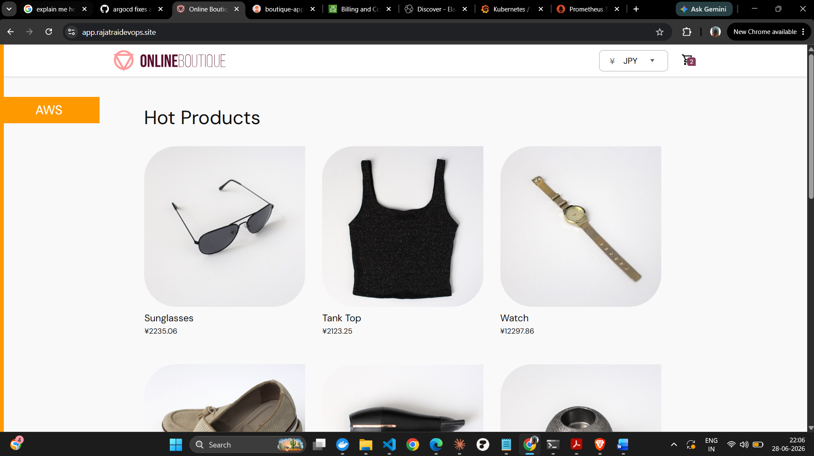

App Deployed on ArgoCD: https://argocd.rajatraidevops.site/applications/argocd/boutique-app?view=tree&resource=
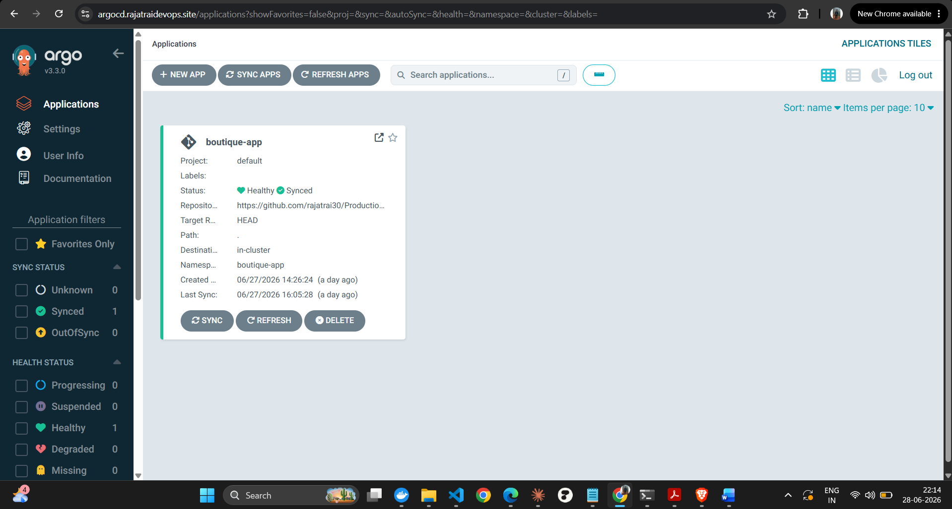

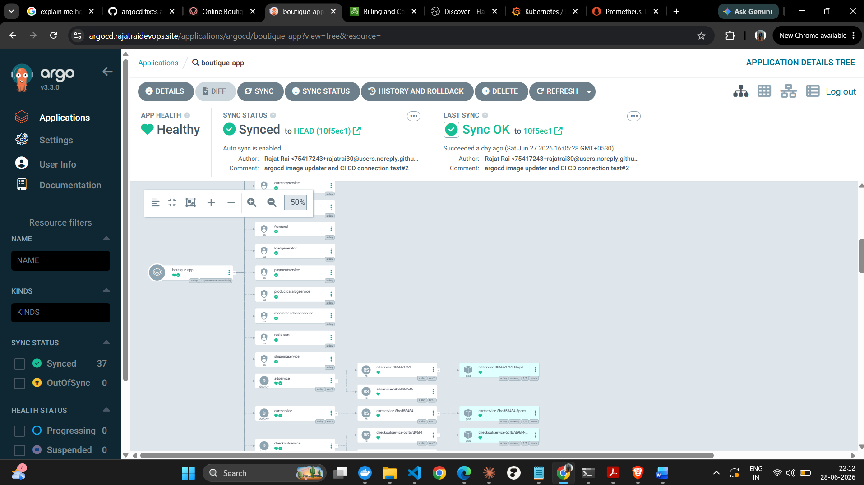
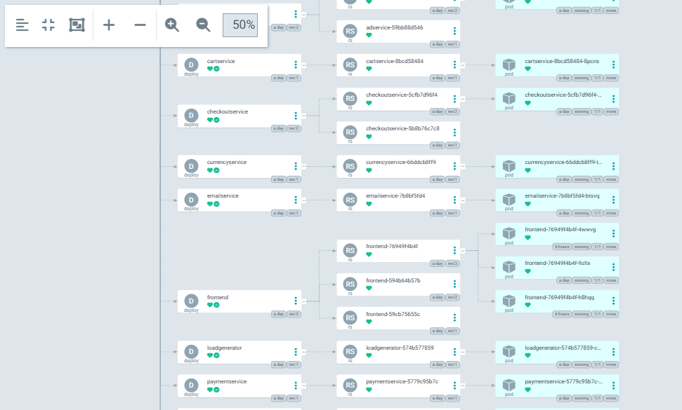

Prometheus: https://prometheus.rajatraidevops.site/query
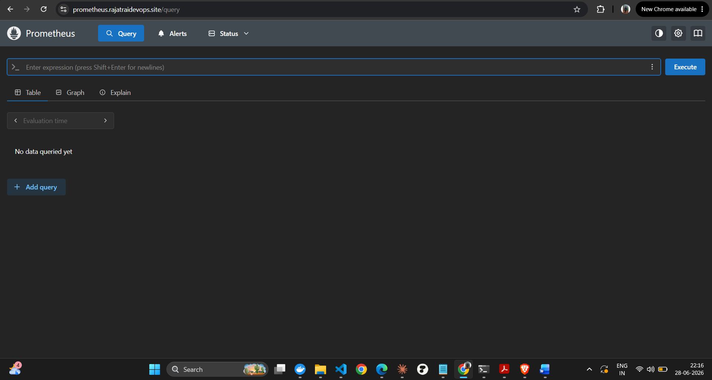

Slack Channel for Alert Manager: alertmanager (Channel) - RAJATRAIDEVOPS - 1 new item - Slack
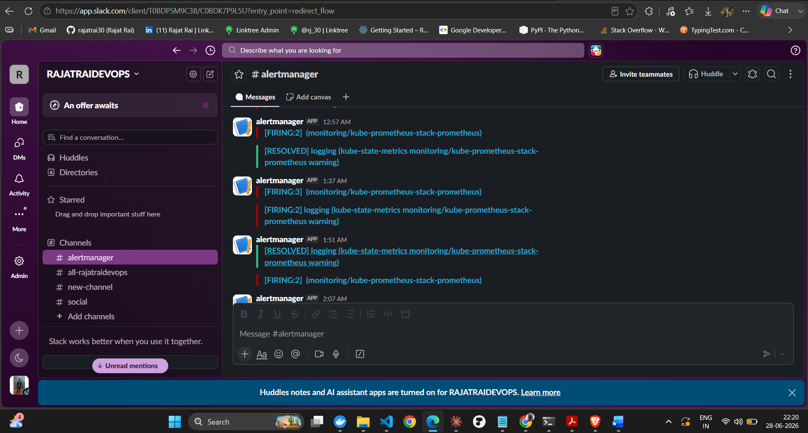

Grafana: https://grafana.rajatraidevops.site/d/7a18067ce943a40ae25454675c19ff5c/kubernetes-networking-pod?orgId=1&from=now-1h&to=now&timezone=utc&var-datasource=default&var-cluster=&var-namespace=boutique-app&var-pod=frontend-76949f4b4f-4wwvg&refresh=10s
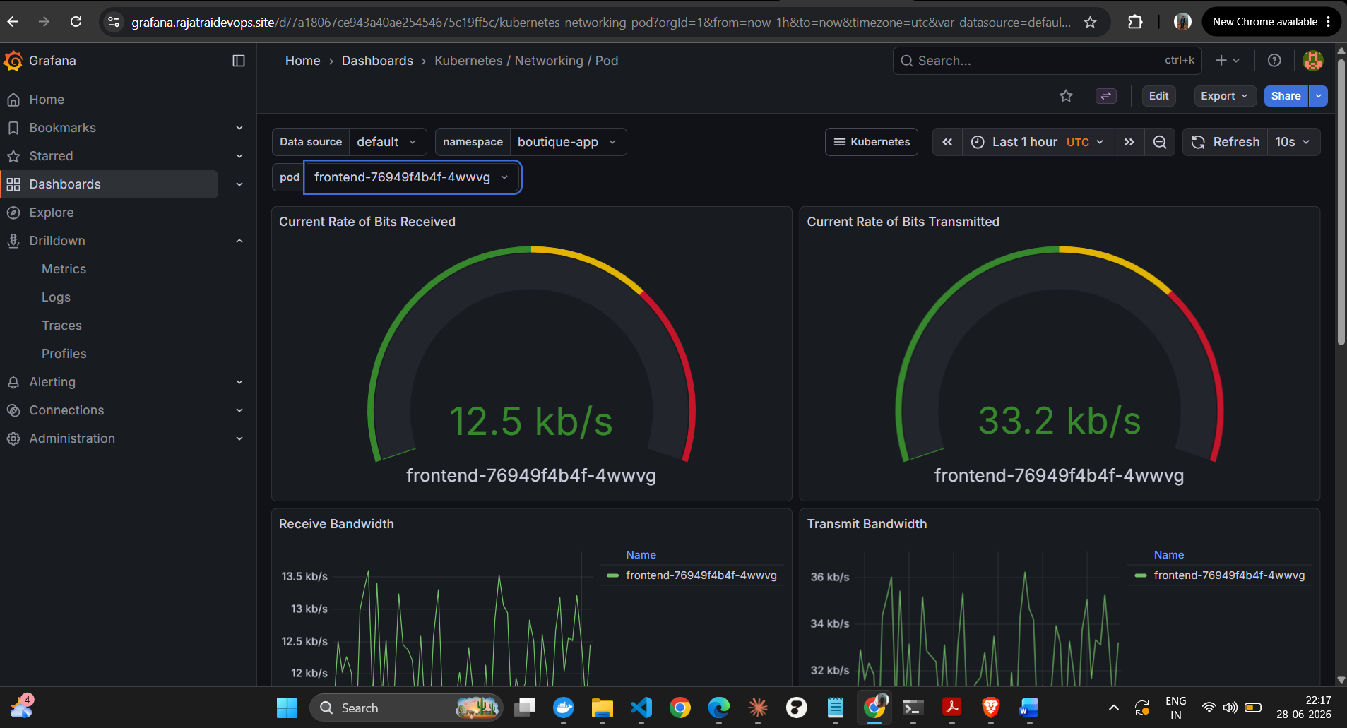

Kibana: https://kibana.rajatraidevops.site/app/discover#/?_tab=(tabId:'3e6827ac-ba7a-461c-9dbb-3df1995f7c3f')&_g=(filters:!(),refreshInterval:(pause:!t,value:60000),time:(from:now-15m,to:now))&_a=(dataSource:(dataViewId:discover-observability-solution-all-logs,type:dataView),filters:!(('$state':(store:appState),meta:(alias:!n,disabled:!f,index:discover-observability-solution-all-logs,key:kubernetes.namespace,negate:!f,params:(query:boutique-app),type:phrase),query:(match_phrase:(kubernetes.namespace:boutique-app))),('$state':(store:appState),meta:(alias:!n,disabled:!f,index:discover-observability-solution-all-logs,key:kubernetes.pod.name,negate:!f,params:(query:currencyservice-66ddcb8ff9-tt8hf),type:phrase),query:(match_phrase:(kubernetes.pod.name:currencyservice-66ddcb8ff9-tt8hf)))),interval:auto,query:(language:kuery,query:''),sort:!(!('@timestamp',desc)))
